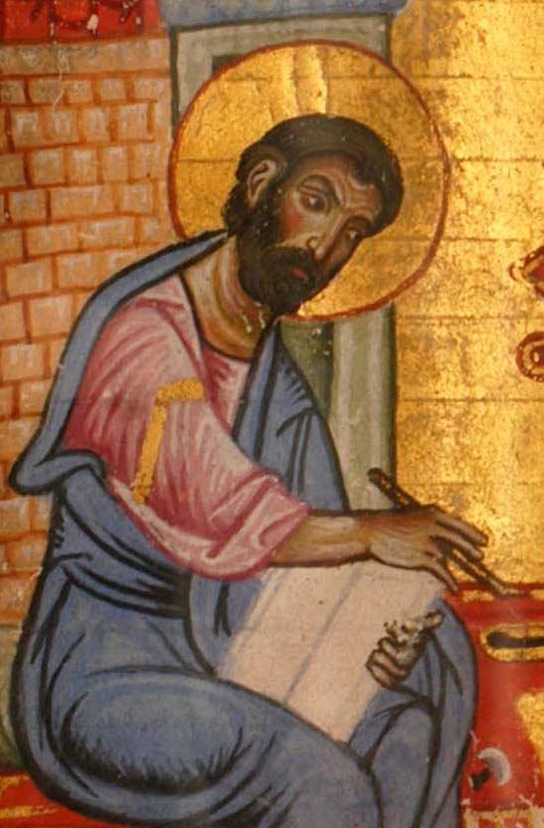
- Mark (a.k.a. John-Mark) was the cousin of Barnabas the apostle and was involved in some missionary activity of the early church (see Acts 12:12,25; 13:5,13; 15:36-39; Col 4:10; Philemon 1:24; 2 Tim 4:11; 1 Pet 5:13)

- The early church’s universal testimony was that Mark indeed recorded the teachings of Peter the apostle about Christ, as he traveled extensively around the Roman world. This early Christian testimony “is so sound that if we did not possess it, we should be compelled to postulate something very much like it.” (Vincent Taylor, Gospel According to St. Mark, 1952, preface, p.vii)
Detail of illuminated miniature depicting St Mark

- Papias (60-140 AD): “And the elder [apostle John] said this also: Mark having become the interpreter of Peter, wrote down accurately everything that he remembered without however recording in order what was either said or done by Christ... So then Mark made no mistake, while he thus wrote down some things as he remembered them; for he made his own care not to omit anything that he had heard, or to set down any false statement therein.” (Eusebius, Ecclesiastical History, chapter 3.39)

- Justin Martyr (100-165 AD): states that Mark was the “memoir” of Peter the apostle (Dialogue with Trypho, chapter 106)

- Irenaeus (130-200 AD): “After their (Paul & Peter’s) departure, Mark, the disciple and interpreter of Peter, did also hand down to us in writing what had been preached by Peter.” (Irenaeus, Against Heresies, chapter 3.1.1)

- Clement of Alexandria (150-215 AD): “After Peter had publicly preached the word in Rome and declared the gospel by the Spirit, many who were present entreated Mark, as one who had followed him for a long time and remembered what he had said, to write down what he had spoken, and Mark after composing the Gospel, presented it to his petitioners. When Peter became aware of it, he neither eagerly hindered nor promoted it.” (Eusebius, Ecclesiastical History, chapter 6.14)

